Name:

ID:

M6 Assignment C1-03 V1

Submit here: <https://docs.google.com/forms/d/e/1FAIpQLSfkhfbqQsymvrPEuwEvigJycyzJxLjDqaWAJTmV2iYXc7936g/viewform>

Part 1:

1. Create the following using HTML, CSS, and JavaScript. When you hover over each element in the periodic table, the background color should change to yellow:

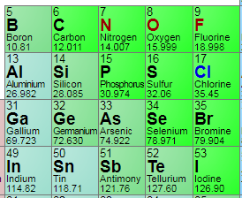

1. Create the following using HTML, CSS, and JavaScript. When you click on the orange ellipse it should change color from orange to pink:

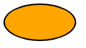

1. Use HTML, CSS, and Javascript to create the following. Whatever the user types in the text input box should be displayed in an h2 element above the text-input:

Before:



After:



Part 2:

1. Which of the following HTML tags is a web page within a webpage:

|  |  |
| --- | --- |
| audio | webpage |
| iframe | internet |
| frame | Editor |
| browser | javascript |

1. Which of the following makes comments for HTML and CSS:

|  |  |
| --- | --- |
| HTML: <!-- ->  CSS: /**/ | HTML: <!-- ->  CSS: // |
| HTML: <--- ->  CSS: /**/ | HTML: //  CSS: // |
| HTML: /**/  CSS: // | HTML: “”  CSS: /**/ |
| HTML: {}  CSS: () | HTML: <!-- 🡪  CSS: “” |